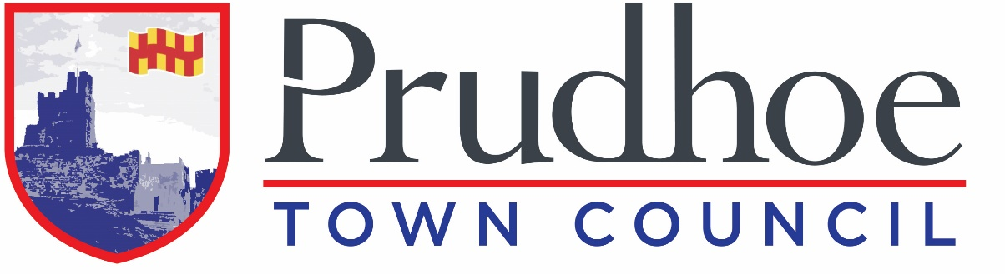

Prudhoe Town Council

The Spetchells Centre
58 Front Street
Prudhoe
Northumberland
NE42 5AA

Administration Assistant – Fixed Term for One Year

Recruitment Pack
Thank you for your interest in Town Council. We are delighted to share the enclosed information about role, and to provide a little background to the Council.

The Council
Prudhoe Town Council is one of 149 Town and Parish Councils in Northumberland. We are the eighth largest in terms of population, based on the most recent 2021 census (10,288).

Northumberland County Council is the Local Authority and is responsible for a number of statutory services. Prudhoe Town Council is the third tier of Local Government. We have a statutory duty to provide allotments, and in accordance with the powers available to us, we provide play areas, litter bins, public seats, bus shelters, Edgewell Cemeteries, Christmas lights, and delivery of town events.

The Town Council is committed to delivering high quality local services. Currently the Council manages a cemetery, four allotment sites, four play areas, public toilets, and the town’s war memorial, in addition to street furniture and environmental services.

The Council is made up of 15 elected members, also called Town Councillors. Each year at the Annual Meeting of the Council a Mayor/Chair of the Council is elected, along with a Vice-Chair.

The Staffing Team
I am the Clerk and Responsible Financial Office of the Council, which is a statutory and legally appointed role. I am responsible for ensuring the Town Council operates legally, and I oversee the Council's administration and Deputy Clerk. I must ensure all decisions of the Council are carried out, and I have overall responsibility for the financial affairs of the Council.

We are a small team who work diligently to execute the decisions of the Council, supporting each other and bringing ideas for improvement forward. We are a hardworking, dedicated, and friendly team, working in an environment where everyone is valued.

The Role – Administration Assistant
We are looking for an enthusiastic and proactive Administration Assistant to join the Clerk in serving Prudhoe Town Council. Full details are in the attached job description.

Salary
£24,413 - £25,583 (SPC 2 – 5) £12.65/hour - £13.26/hour (Pro Rata) depending upon qualifications and experience.

Hours of work
20 hours/week. Office hours Monday – Thursday 10am – 3pm, plus regular evening meetings (monthly), and occasional weekend working for events.

Place of work
Room 2.06 The Spetchells Centre, Prudhoe, NE42 5AA.

Other benefits
- National Terms and Conditions of Employment (NJC Green Book).
- NEST Pension Scheme
- In addition to the normal bank and public holidays, 24 working days’ leave in each leave year (pro rata for part-time employees).
- 3 extra statutory days (pro rata for part-time employees). The timing of these extra-statutory holidays will be by mutual arrangement and must be taken at times convenient to the Council, for example during the office closure over the Christmas period.
- Commitment to ongoing training and development.

How to apply
Please provide a covering letter and complete the enclosed application form. You are advised to review the job description and person specification in full before applying. You must complete all sections of the application form. Please note CV’s will not accepted.

Covering letters and completed application forms can be posted to the address above, or emailed to clerk@prudhoetowncouncil.gov.uk

Closing date and selection
The closing date for applications is 12 noon on Friday 4th September 2026. All applicants will be acknowledged. Shortlisted applicants will be invited to attend an interview, with the date and time to be confirmed.

If you have any questions, please contact me.

Enclosed
- Job Description with Person Specification
- Application Form

Yours sincerely
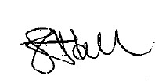

Shirley Ann Gaut Hall
Town Clerk

www.prudhoetowncouncil.gov.uk
Email: clerk@towncouncil.gov.uk
Office Telephone Number: (01661) 835487
Mobile Telephone Number: 07495856624

