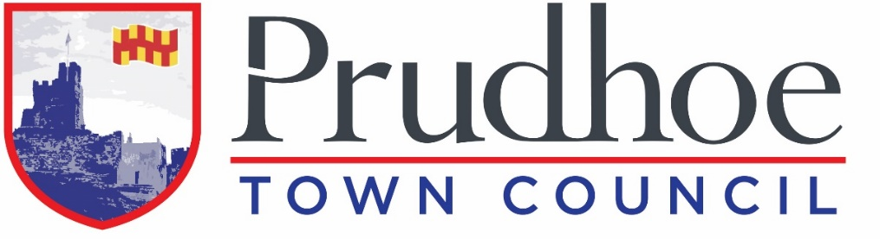

JOB DESCRIPTION
ADMINISTRATION OFFICER (Fixed Term for One Year)

Overall Responsibilities
Providing administrative support to the Clerk and Councillors.

Answering telephone calls and directing calls and other correspondence to appropriate staff. Dealing with enquiries from the public about council services/activities and referring to Councillors or to other agencies/where appropriate.

Maintaining office supplies.

Specific Statutory Responsibilities
- Contributing to the observation of legal, statutory and other provisions governing or affecting the running of the Council.
- Assist in the production, collation and delivery of agenda notices and associated papers for meetings of the Council and its Committees.
- Ensure that agendas, associated papers and minutes of the Council and its Committees are uploaded to the Council’s website in line with legal provisions that govern the Council.
- Attending Council meetings as and when required.
- Maintaining the official file of the minutes of meetings in line with legislation.
- Receive correspondence by post and email; deal with any enquiries or pass these on to the appropriate body/person.
- Issuing correspondence following the instructions of the Clerk.
- Acting as a representative of the Council as required.

Statutory Financial Responsibilities
- Receiving invoices for goods and services to be paid for by the Council, and ensuring such accounts are passed directly to the Clerk.
- Issuing invoices on behalf of the Council, as directed by the Clerk, and entering data to maintain a system of control.
- Issuing purchase orders on behalf of the Council and entering data to maintain a system of control.
- Contributing to ensuring financial efficiencies are sought, ensuring value for money.

Service and Administrative Responsibilities
- Assisting in the efficient running of the Town Council office, reviewing and monitoring systems, processes and procedures and updating where appropriate. Make best use of appropriate information technology.
- Assisting in the administration of the Council’s website and social media presence.
- Receiving planning notifications and decisions and sharing with Councillors as delegated by the Clerk.
- Assist and support the Clerk in providing bereavement administration and support in regard to Edgewell Cemetery, to funeral directors, memorial masons and the general public:-
- Ensure all cemetery paperwork is completed and processed as a priority and cemetery records and deeds are maintained accurately.
- Liaise with external partners and the general public, to book funerals and memorial work, in a timely and professional manner.
- Issue cemetery invoices and input to system to ensure proper credit control.
- Organising and setting up meetings both internally and externally, issuing invites and booking rooms.
- Receiving, recording and reporting issues with Town Council assets and ensure these are passed to the Clerk.
- Receiving, recording and reporting issues with service delivery provided by partners or contractors, and ensuring these are shared appropriately.
- Assisting in the organisation and delivery or Council events and Council supported events (please see Events list below.)
- Acting as a representative of the Council as required, including attending meetings with key stakeholders, positively promoting the Council within the local community and being one of the Council’s public facing contacts.

Other Responsibilities
- Attending training courses the support the role and contribute to personal and professional development.
- Carrying out any other relevant duties which may be assigned from time to time by the Council.

Functions & Services

Edgewell Cemetery

Play Areas:-
- Castledene Play Area
- Highfield Park
- The Copse Play Area
- West Mickley Play Area

Allotments:
- Castledene
- Edgewell
- Redwell
- Stonyflat Bank

- West Road Public Toilets
- Public Seats
- Bus Shelters
- Litter Bins
- Christmas Lights
- Floral Bedding, Hanging Baskets, Planters, and Gateways
- Lychgate War Memorial

Events
Highfield Fest Family Fun Day
Prudhoe in Bloom
Christmas Lights Switch-on
The Miners Race
Remembrance Parade and Service

PERSON SPECIFICATION
ADMINISTRATIVE OFFICER

 | Essential | Desirable
Educational Qualifications | Good general education demonstrating numeracy and literacy; GCSE (or equivalent), including English and Mathematics (A-C/9-4 or equivalent)  Commitment to complete study for ‘Introduction in Local Council Administration’ (ILCA) | Commitment to continual professional development and a willingness to study  I.T Qualification; ECDL, Word/Text Processing
Skills | High quality written and verbal communication skills, able to exchange information verbally and in writing to others  Promote equal opportunities and diversity in all aspects of work  Always maintains strict confidentiality and professionalism  Works efficiently and effectively to time measured tasks  Recognises when queries/situations need to be sign-posted or referred  Able to organise and prioritise workload  Able to work independently within recognised procedures whilst using own initiative
Knowledge/ Experience | Can provide high-quality and accurate administrative support  Can product professional and timely documents and correspondence  Good working knowledge of Microsoft Office and Microsoft Outlook  Can maintain a professional online presence via website and social media platform | Assisting with functions and events  Uploading to website  Uploading to a social media page  Advance working knowledge of Microsoft Office (or equivalent)  Local Government Administration
Personal Qualities | Able to work within strict codes of conduct, policies, and procedures  Able to establish good working relationships with wide-ranging people  Self-motivated and resourceful  Excellent organiser
Other | Able to attend monthly and other ad hoc evening meetings  Able to work occasional weekends for Town Council events

